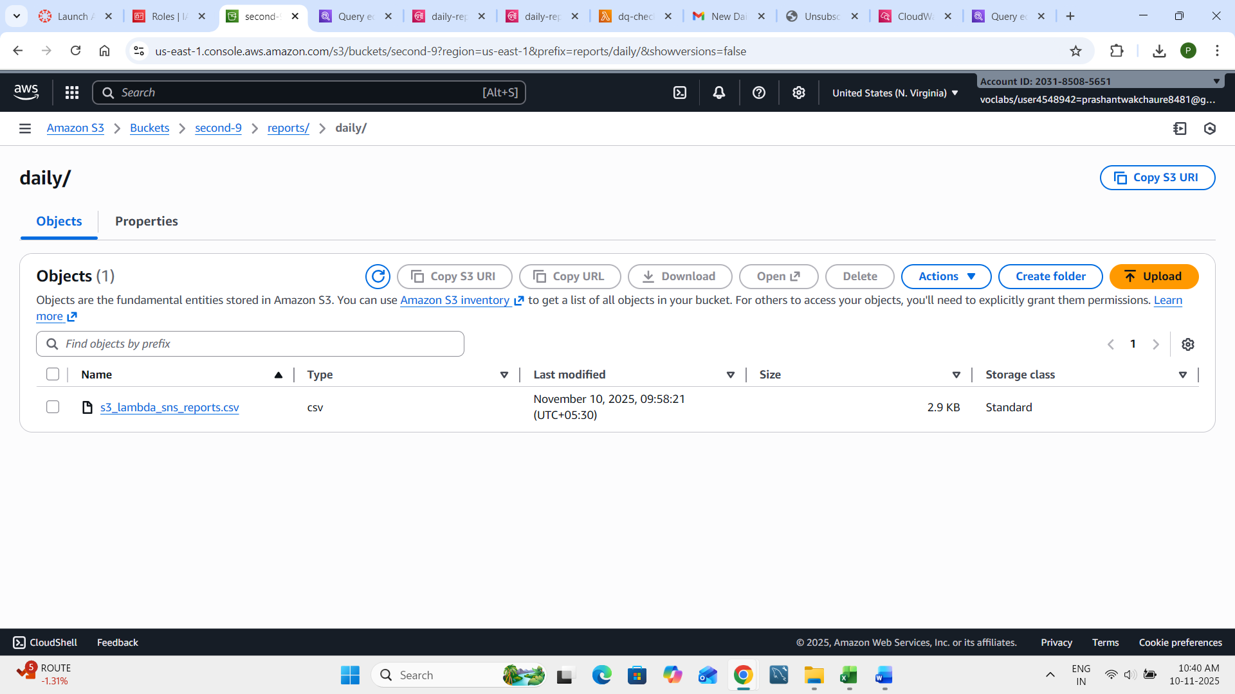

Lamda code-

import boto3
import csv
import io
import json
import logging

logger = logging.getLogger()
logger.setLevel(logging.INFO)

s3 = boto3.client('s3')
sns = boto3.client('sns')

SNS_TOPIC_ARN = "arn:aws:sns:us-east-1:203185085651:daily-report-alerts"

def lambda_handler(event, context):
record = event['Records'][0]
bucket = record['s3']['bucket']['name']
key = record['s3']['object']['key']

# Read the CSV file directly from S3
obj = s3.get_object(Bucket=bucket, Key=key)
data = obj['Body'].read().decode('utf-8').splitlines()
reader = csv.DictReader(data)

bad_records = 0
for row in reader:
if not row['order_id'] or row['order_id'].strip() == '' or float(row['price'] or 0) < 0:
bad_records += 1

logger.info(f"Checked file {key}, found {bad_records} bad records")

if bad_records > 0:
message = f"⚠️ {bad_records} bad records found in {key}"
sns.publish(
TopicArn=SNS_TOPIC_ARN,
Subject="Data Quality Alert",
Message=message
)
logger.info("SNS alert sent.")
else:
logger.info("No bad records found.")

return {"statusCode": 200}

